# **CIS 5200 Term Project Tutorial**

#### **Authors:**

#### **Valerie Carisma Alan Chan Melissa Hamamoto Andrew Lai Medrik Minassian**

#### **Instructor:**

#### [**Jongwook Woo**](https://www.linkedin.com/in/jongwook-woo-7081a85)

#### **Date: 12/4/2018**

**CIS5200 Term Project Tutorial**

**LAPD Crime Data Analysis using Hive and Tableau**

**Objectives:**

In this hands-on lab, you will learn to:

* Download data and upload to HDFS
* Connect to Hive
  + Create a database
  + Create tables
  + Load data into tables
  + Run HiveQL commands to perform analysis on the data
  + Download Output File to Local Computer
* Visualization with Tableau and Excel 3D Map

**Platform Specs**

* Oracle Big Data Compute Edition
* Hadoop Version: Hadoop 2.7.1.2.4.2.0-258
* CPU Speed: Intel Xeon E5-2699C v4 @ 2.20GHz
* # of Cores: 88 (22*4 CPUs)
* # of Threads 176 (88*2)
* Oracle Big Data Compute Edition: 5 nodes
* OCPUs: 10
* Memory: 150 GB
* Storage: 678 GB
* HDFS Capacity: 147 GB

**Step 1: Create Directory and Download LA Data**

1. **Create a directory to store downloaded LA data**

Begin this lab by creating a directory called “la” to store our downloaded data.

To make the directory run the command:

**mkdir la**

To check that the directory has been successfully created, list files by running the command:

**ls**

After confirming that the directory has been created, we need to change our current working directory to la.

To do this we need to use the CD command:

**cd la**

Now that we have change our current working directory to la, confirm by printing the working directory using the command:

**pwd**

The result of these four commands should look like this.

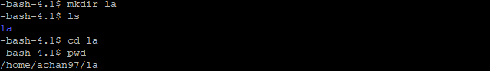

1. **Download LA crime data FROM data.gov through wget**

For this lab we will be using the datasets for “LAPD Calls for Service” from the years 2010 through 2018. To download the data we will be using the command **wget**, this allows us to retrieve content from web servers. For this lab, we will be downloading datasets from Data.gov. We will use the **-O** parameter with wget to allow us to name the files we download.

First, start by confirming that our current working directory la is empty with the command ls:

**ls**

After confirming that the directory is empty we can begin downloading our datasets.

**wget -O 2010.csv 'https://data.lacity.org/api/views/iy4q-t9vr/rows.csv?accessType=DOWNLOAD'**

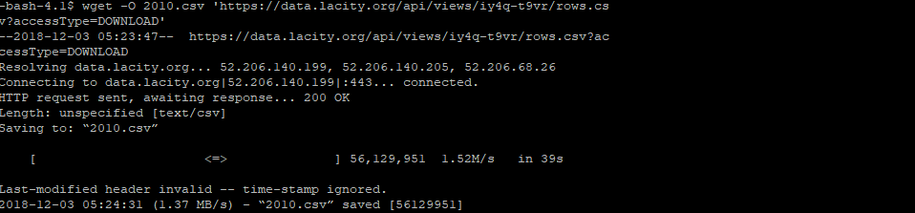

**wget -O 2011.csv 'https://data.lacity.org/api/views/4tmc-7r6g/rows.csv?accessType=DOWNLOAD'**

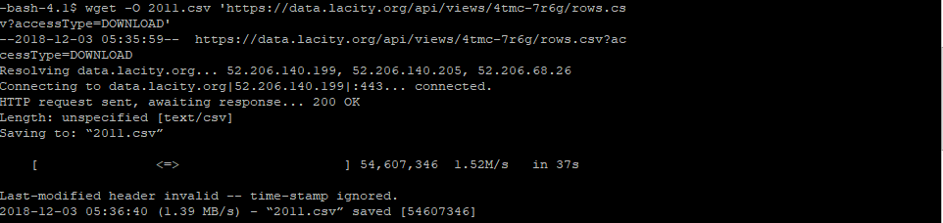

**wget -O 2012.csv 'https://data.lacity.org/api/views/i7pm-cnmm/rows.csv?accessType=DOWNLOAD'**

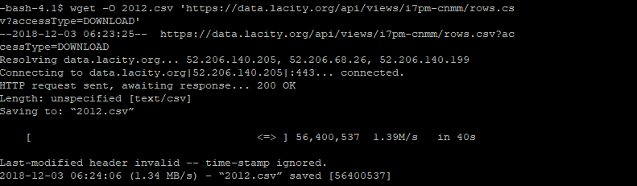

**wget -O 2013.csv 'https://data.lacity.org/api/views/urhh-yf63/rows.csv?accessType=DOWNLOAD'**

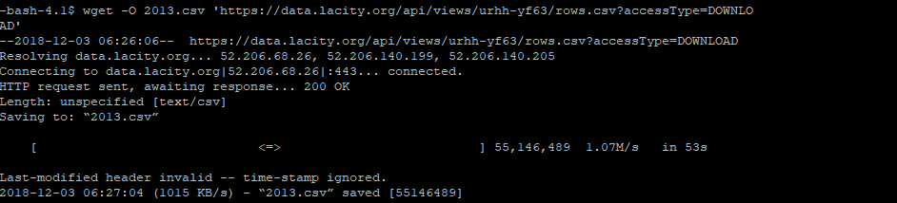

**wget -O 2014.csv 'https://data.lacity.org/api/views/mgue-vbsx/rows.csv?accessType=DOWNLOAD'**

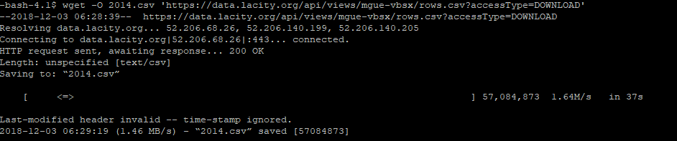

**wget -O 2015.csv 'https://data.lacity.org/api/views/tss8-455b/rows.csv?accessType=DOWNLOAD'**

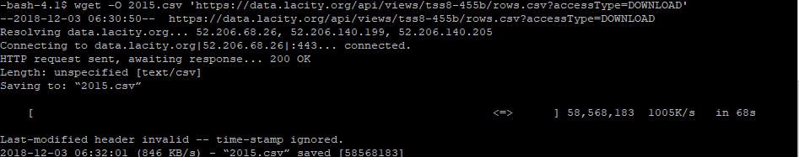

**wget -O 2016.csv 'https://data.lacity.org/api/views/xwgr-xw5q/rows.csv?accessType=DOWNLOAD'**

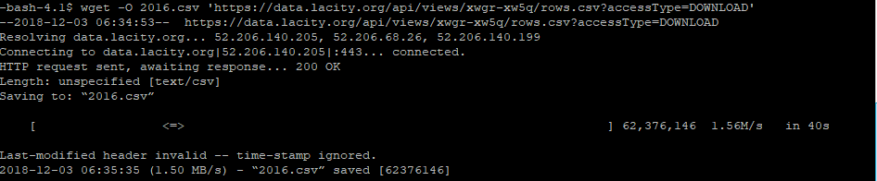

**wget -O 2017.csv 'https://data.lacity.org/api/views/ryvm-a59m/rows.csv?accessType=DOWNLOAD'**

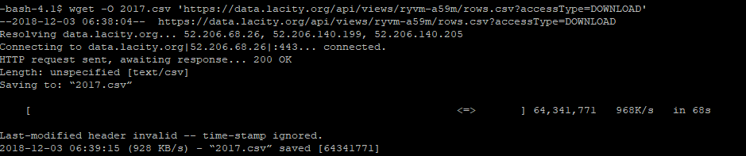

**wget -O 2018.csv 'https://data.lacity.org/api/views/nayp-w2tw/rows.csv?accessType=DOWNLOAD'**

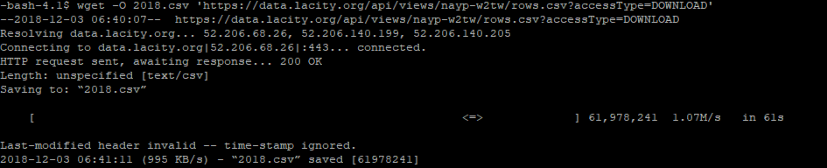

**wget -O districts.kml 'https://opendata.arcgis.com/datasets/4398360b1a0242b78904f46b3786ae73_0.kml'**

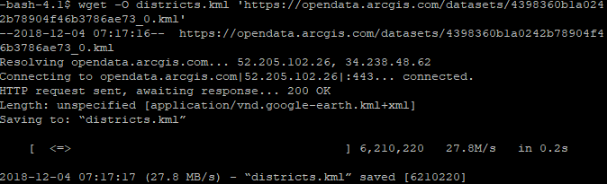

**wget -O la_crime.csv 'https://data.lacity.org/api/views/y8tr-7khq/rows.csv?accessType=DOWNLOAD'**

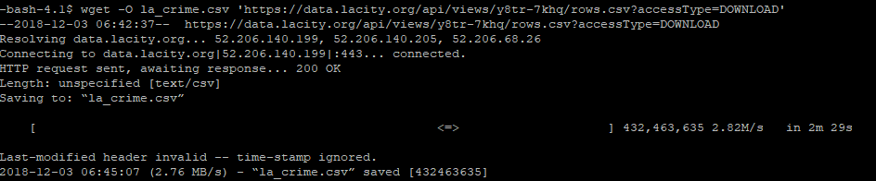

**wget -O stops.csv 'https://data.lacity.org/api/views/ci25-wgt7/rows.csv?accessType=DOWNLOAD'**

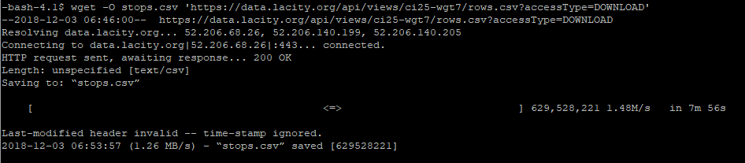

**ls**



**Step 2: Upload data to HDFS**

1. **Create a directory in HDFS for crime data**

To keep things neat we will create a directory la within Hadoop and do all our work there. We can invoke commands to Hadoop with hdfs dfs. Like earlier we will run mkdir la again, but this time with to Hadoop:

**hdfs dfs -mkdir la**

After creating the directory check that it exists:

**hdfs dfs -ls la**

1. **Upload data into HDFS**

Now that we have a directory to upload to, use the **put** command and upload our files to the la directory in Hadoop:

**hdfs dfs -put ./2010.csv ./la**

**hdfs dfs -put ./2011.csv ./la**

**hdfs dfs -put ./2012.csv ./la**

**hdfs dfs -put ./2013.csv ./la**

**hdfs dfs -put ./2014.csv ./la**

**hdfs dfs -put ./2015.csv ./la**

**hdfs dfs -put ./2016.csv ./la**

**hdfs dfs -put ./2017.csv ./la**

**hdfs dfs -put ./2018.csv ./la**

Confirm that the files are in the directory:

**hdfs dfs -ls la**

1. **Change permissions of files to allow write access**

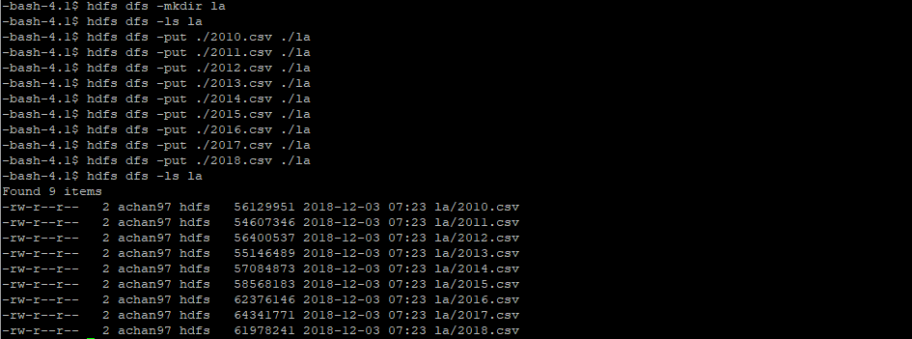

Now that the files have been uploaded to hdfs we need to change permissions of the files so hdfs has write access. The following command gives write access of the directory la and its files:

**hdfs dfs -chmod -R o+w la/**

There will now be a “w” in the last group of permissions. Confirm that hdfs now has write access to the files by listing the directory again:

**hdfs dfs -ls la**

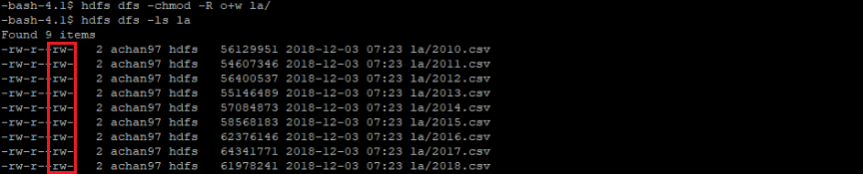

**Step 3: Connect to Beeline and Analyze Data**

1. **Connect to Beeline**

We need to connect to hdfs to analyze our data. For this lab, we will connect using beeline. The beeline command will be used to initiate the connection. A connect command will then be required. When prompted for a password enter nothing and press enter.

**Beeline**

**!connect jdbc:hive2://cis5200-bdcsce-4.compute-608214094.oraclecloud.internal:2181,cis5200-bdcsce-2.compute-608214094.oraclecloud.internal:2181,cis5200-bdcsce-3.compute-608214094.oraclecloud.internal:2181/;serviceDiscoveryMode=zooKeeper;zooKeeperNamespace=hiveserver2?tez.queue.name=interactive bdcsce_admin**

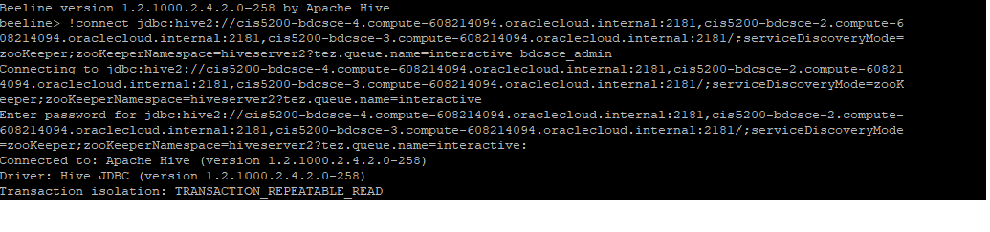

1. **Create a Database**

Before we start creating tables, create a database to house different datasets. Not only is it good for housekeeping, it also lowers chances of another user accessing the wrong tables. A database can be created through:

**CREATE DATABASE achan97;**

Test that our database has been made with **show**:

**Show databases;**

After confirming that the database has been made we can access through the **use** command:

**Use achan97;**

Confirm that there are no tables within the database by showing tables:

**Show tables;**

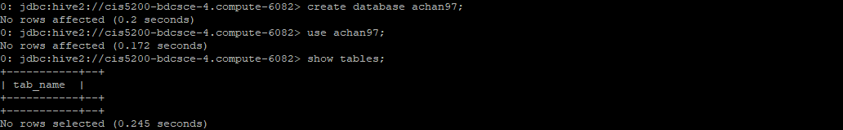

1. **Use created Database to analyze data**

Now that we are working from a dedicated database, we can start creating tables. The first table we will need to make is the calls table. This table will consist of data from the years 2010 to 2017. Data from 2018 will need to be separated from these other years because the 2018 calls csv does not conform to the previous years. We will need to take a few more steps to combine the data.

The calls table will consist of 7 columns:

**Incident_Number Area_Occurred Reporting_District Dispatch_Date Dispatch_Time Call_Type_Code Call_Type_Description**

To keep things simple all data types can be set as a string. Creating the table as an external table retains the data even when the table is dropped.

**CREATE EXTERNAL table calls**

**(Incident_Number string,**

**Reporting_District string,**

**Area_Occurred string,**

**Dispatch_Date string,**

**Dispatch_Time string,**

**Call_Type_Code string,**

**Call_Type_Description string)**

**ROW FORMAT DELIMITED FIELDS TERMINATED BY ','**

**STORED AS TEXTFILE LOCATION '/user/achan97/la/table/calls';**

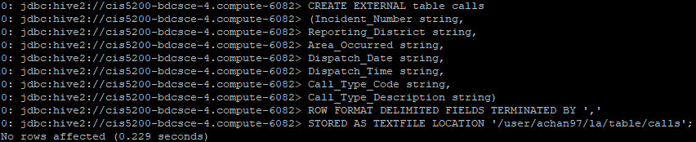

After the table has been created confirm with:

**Show tables;**

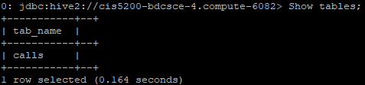

Now check that the table has the right data type:

**Describe calls;**

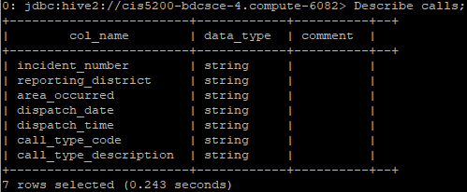

The calls table we just made is empty, so we will need to load data into it. We will load service call data from 2010 to 2017 into the calls table. The following load data inpath commands will move the files we uploaded into hdfs earlier into the location we chose when we made our calls table.

**LOAD DATA INPATH '/user/achan97/la/2010.csv' INTO table calls;**

**LOAD DATA INPATH '/user/achan97/la/2011.csv' INTO table calls;**

**LOAD DATA INPATH '/user/achan97/la/2012.csv' INTO table calls;**

**LOAD DATA INPATH '/user/achan97/la/2013.csv' INTO table calls;**

**LOAD DATA INPATH '/user/achan97/la/2014.csv' INTO table calls;**

**LOAD DATA INPATH '/user/achan97/la/2015.csv' INTO table calls;**

**LOAD DATA INPATH '/user/achan97/la/2016.csv' INTO table calls;**

**LOAD DATA INPATH '/user/achan97/la/2017.csv' INTO table calls;**

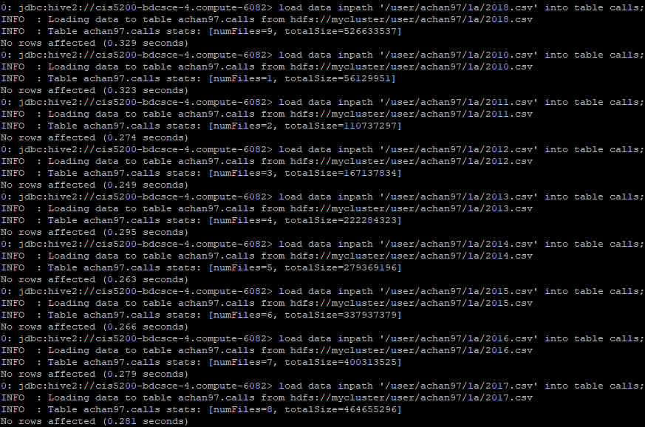

We can confirm that the 8 csv files have been move to their new location by listing the files in a bash terminal.

**hdfs dfs -ls la/table/calls/**

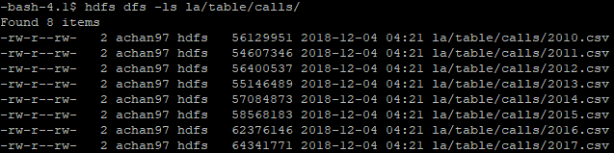

Our table will then need to be tested for valid data. This can be done by running a select all query from the table calls to test it. We will add a limit of 10 results as we do not need to see every row.

**SELECT * FROM calls LIMIT 10;**

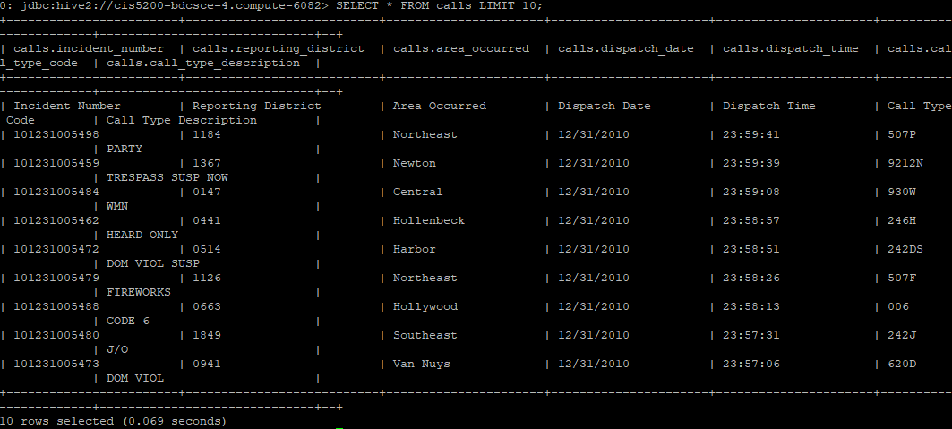

With our first table tested and working, we can move to our next table, where we will be repeating the process with a few changes. First, we will skip the header in this file as it is different from the other years. Second, notice also how the 2nd and 3rd columns are switched around in the calls2018 table.

**CREATE EXTERNAL table calls2018**

**(Incident_Number string,**

**Area_Occurred string,**

**Reporting_District string,**

**Dispatch_Date string,**

**Dispatch_Time string,**

**Call_Type_Code string,**

**Call_Type_Description string)**

**ROW FORMAT DELIMITED FIELDS TERMINATED BY ','**

**STORED AS TEXTFILE LOCATION '/user/achan97/la/table/calls2018'**

**TBLPROPERTIES ('skip.header.line.count'='1');**

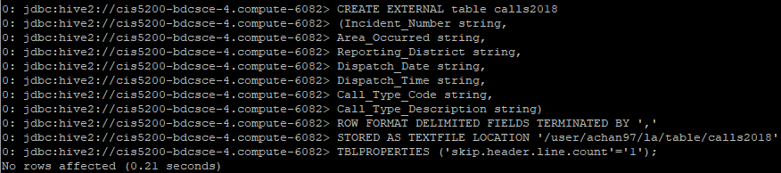

Like the calls table, we will need to confirm it exists and has the string data type. We will then load the 2018 csv into the table, confirm its relocation and test the table.

**Show tables;**

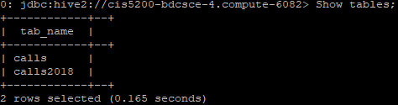

**Describe calls2018;**

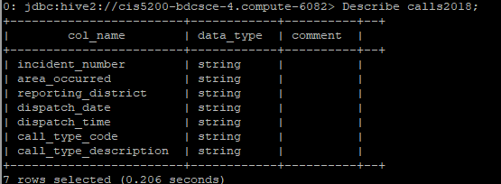

**LOAD DATA INPATH '/user/achan97/la/2018.csv' INTO table calls2018;**



**hdfs dfs -ls la/table/calls2018**



**SELECT * FROM calls2018 LIMIT 10;**

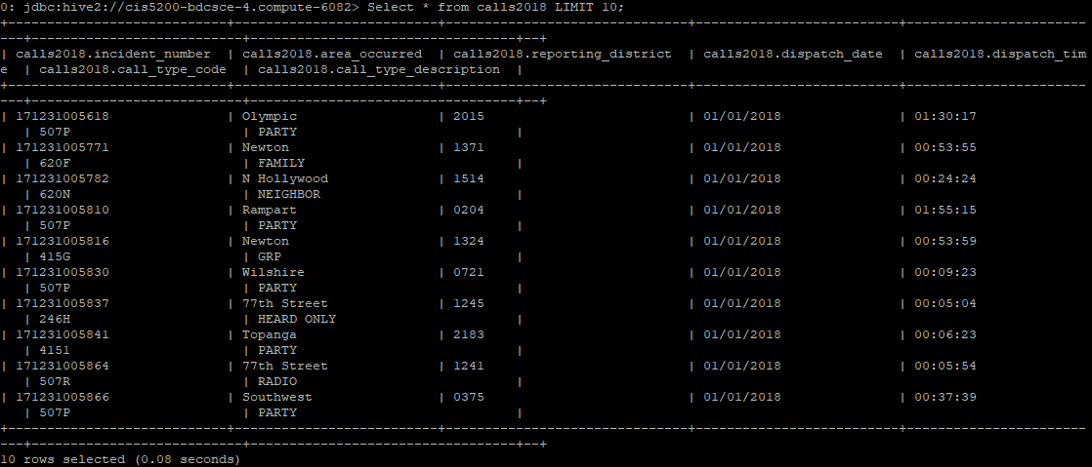

**SELECT COUNT(Incident_Number) AS total_incidents FROM calls;**

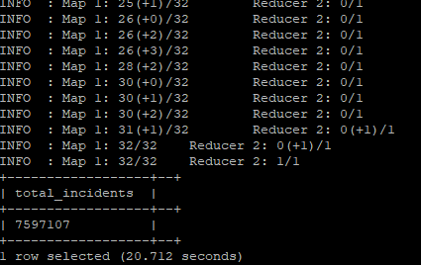

**SELECT COUNT(Incident_Number) AS total_incidents FROM calls2018;**

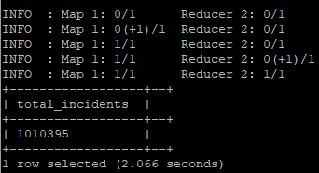

For this lab we will be looking at the top 3 areas with the most calls. Because our data has been split into two tables we will need to combine them in our query using **union all**. The following query contains a subquery that selects the top 3 areas with the most calls from the years 2010 to 2018.

**SELECT area_occurred,SUM(total) AS total_incidents**

**FROM**

**(SELECT area_occurred,COUNT(incident_number) AS total**

**FROM calls**

**GROUP BY area_occurred**

**UNION ALL**

**SELECT area_occurred,COUNT(incident_number) AS total**

**CALLS calls2018**

**GROUP BY area_occurred)**

**AS count**

**GROUP BY area_occurred**

**ORDER BY total_incidents**

**DESC**

**LIMIT 3;**

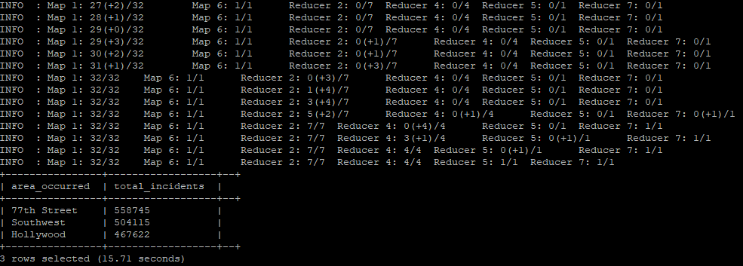

When we made our first table, we did not drop the headers from years 2010 to 2018. We will now create a newcalls table with these extra rolls removed from our data. Create a table from calls that excludes any rows with the string “Incident_Number” in the column incident_number. Again, test that the table has been successfully created. Notice how there were no data types set for this table. This is because the newcalls table inherits the data types from the calls table. When the the describe command is run later, notice how the data types are the same as the calls table.

**CREATE table newcalls**

**ROW FORMAT DELIMITED FIELDS TERMINATED BY ','**

**AS**

**SELECT * FROM calls**

**WHERE incident_number != 'Incident_Number';**



**Show tables;**

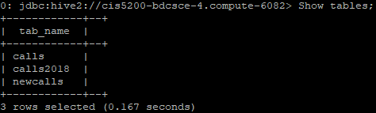

**Describe newcalls;**

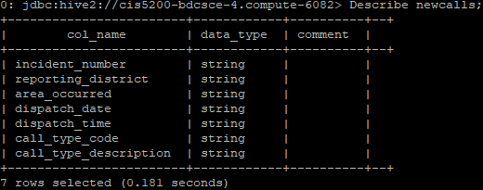

Now, check that the newcalls table does not include any rows with the field “Incident_Number” from incident_number.

**SELECT COUNT(incident_number) FROM newcalls**

**Where incident_number = 'Incident_Number';**

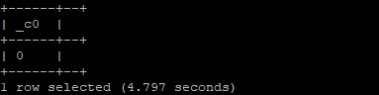

Now that all our data from 2010 to 2017 has been entered, we will need to **insert** the 2018 data. When the data from 2018 is added into the newcalls table, the columns will need to be reordered to match the order of the other datasets.

**INSERT INTO table newcalls**

**SELECT Incident_Number,Reporting_District,Area_Occurred,Dispatch_Date,Dispatch_Time,Call_Type_Code,Call_Type_Description**

**FROM calls2018;**

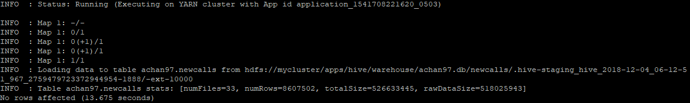

To confirm that the 2018 data has been added to newcalls, Select all data from newcalls with a dispatch data ending in the year 2018. Add a limit of 10 to the query because we don’t need to check every row.

**SELECT * FROM newcalls**

**WHERE Dispatch_Date like '%2018' limit 10;**

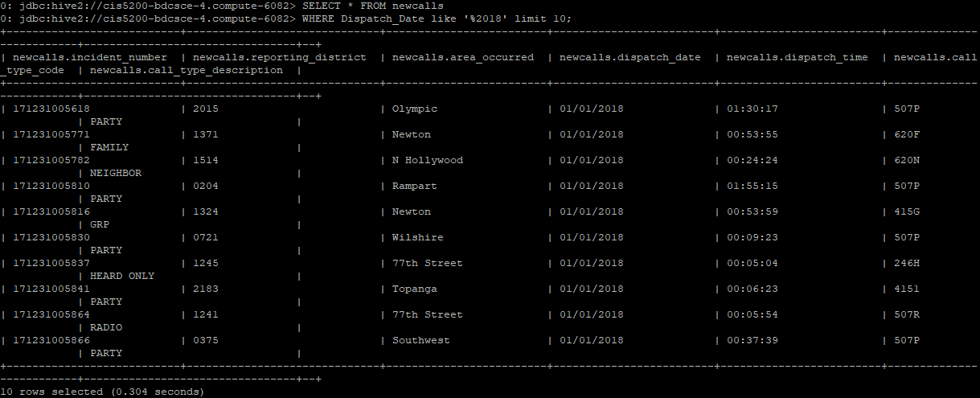

Earlier we ran a query that showed us the top 3 areas with the most service calls. We will now create a table just for the 77th street area, the area with the most service calls, from our newcalls table. Then we will check again to make sure that the table works.

**CREATE table 77th_street**

**ROW FORMAT DELIMITED FIELDS TERMINATED BY ','**

**STORED AS TEXTFILE LOCATION '/user/achan97/la/77th_street'**

**AS**

**SELECT * FROM newcalls**

**WHERE area_occurred == '77th Street';**

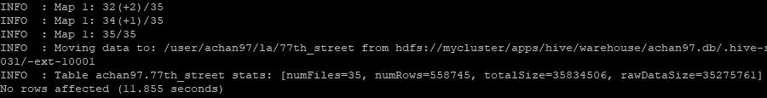

**Show tables;**

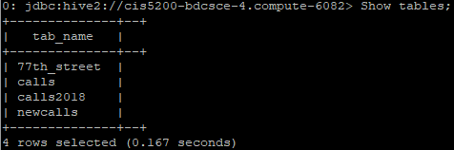

**Describe 77th_street;**

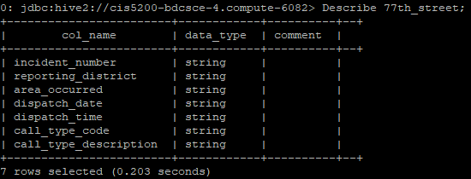

**SELECT * FROM 77th_street LIMIT 10;**

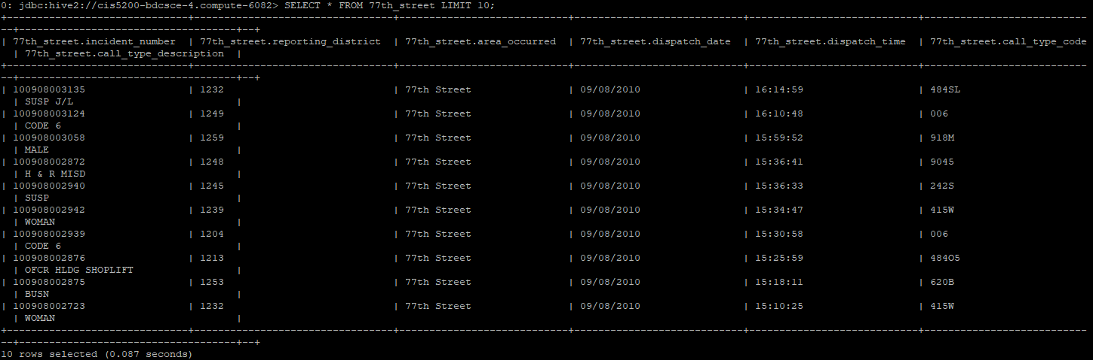

Now that we have a finalized table with an area to work with, we will check for the top 10 types of calls made in the area.

**SELECT Call_Type_Description,COUNT(Call_Type_Description) AS times**

**FROM 77th_street**

**GROUP BY Call_Type_Description**

**ORDER BY times**

**DESC**

**LIMIT 10;**

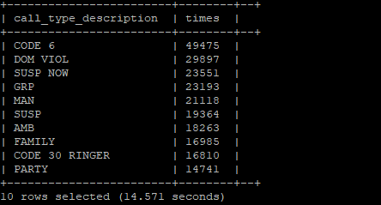

With our tables created in hdfs, we will now download the ones we want to use into the local system. Use get and list in a bash terminal to confirm that they have been extracted.

**hdfs dfs -get la/77th_street**

**ls**

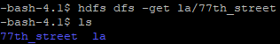

After the table has been downloaded to the local system, change our directory to the directory that gets created when we downloaded the 77th street table.

**cd /home/achan97/77th_street**

**pwd**

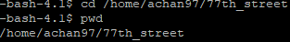

Now that we are in 77th_street list the files in the directory.

**ls**

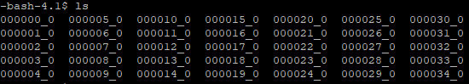

The data extracted from hdfs has been put into parts and needs to be concatenated to make viewing easier. This can be done through:

**cat * > 77th_street.csv**

After running this command check that our new file 77th_street.csv has been made.

**ls**

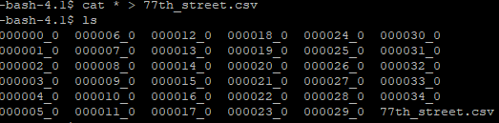

**Step 4: Visualize data into Excel**

1. **Download psftp to download data to local computer**

There are many ways to download data to a local computer. One way on Windows is through psftp.exe; psftp can be download by accessing: https://www.chiark.greenend.org.uk/~sgtatham/putty/latest.html. Download the client that matches the version of your operating system.

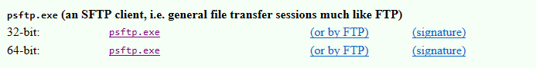

Browse to where psftp downloaded and run the executable. Connect to the Hadoop cluster through its IP address. We will need to use the **open** command to open a connection to the IP with:

**open 129.150.128.177**

Psftp will then prompt for your cloud username and password. After signing in, we will need to change our directory to where we stored the 77th_street.csv file earlier. Change the directory with the command:

**cd /home/achan97/77th_street**

To download the file to our local computer we will need to use the **get** command again:

**get 77th_street.csv**

Now that we have downloaded the 77th street data, we will also need to download the spatial map file districts.kml. We will need to change our directory again to where the spatial map file is stored. We can do so through the command:

**cd /home/achan97/la**

Again, we can download the file using **get**:

**get districts.kml**

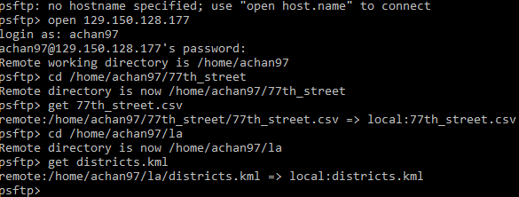

By default, files downloaded through psftp will be downloaded to the same location psftp was ran.

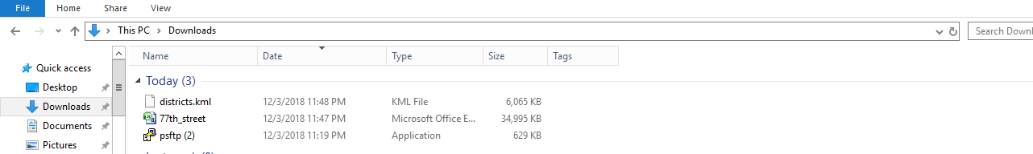

1. **Setup 77th street data to work with Excel 3d maps**

Before we can use the two files we just downloaded in Excel 3d maps, we will need to make some changes to the file we just downloaded. First, the 77th_street.csv file is missing headers. Second, Excel 3d maps only works with the .xlsx file extension. We will need to add the following 7 headers into the csv file.

**Incident_Number Area_Occurred Reporting_District Dispatch_Date Dispatch_Time Call_Type_Code Call_Type_Description**

To add the headers, we will first need to insert a new row at the top of the dataset. Select the cell A1 and right click. Click on insert.

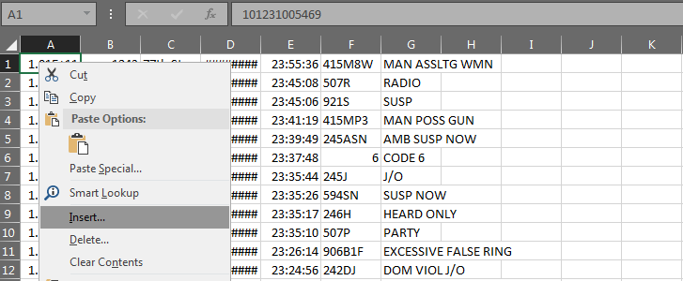

A new window will pop up. We want to insert an entire row.

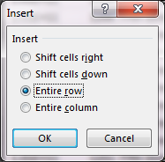

After inserting the row, copy and paste the 7 headers into the first cell. Next, we will need to split the headers into their own columns. We can do this through Excels’ Text to Column Wizard. Select fixed width and pressed finish. The headers should split into into the 7 columns.

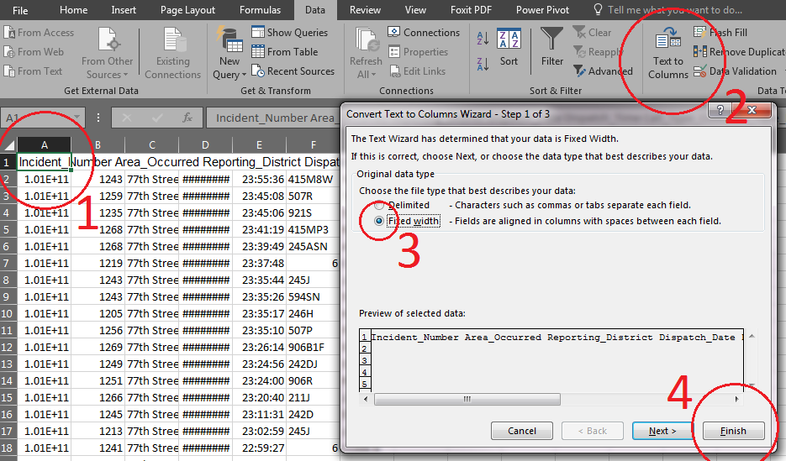

We will now need to save the file as an .xlsx file. Save as and browse for the file extension .xlsx.

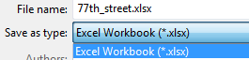

Now that we have added headers to our dataset and saved the file as .xlsx. We can head over to Excel 3d maps. Open our new file and highlight all the data with CTRL+A. Then insert a 3d map.

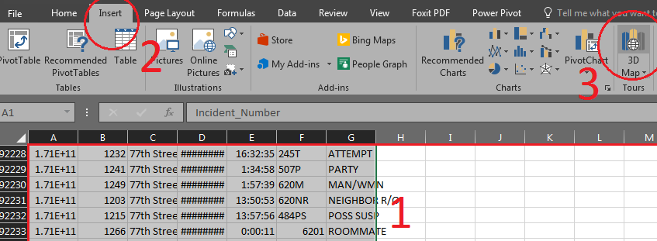

1. **Visualize data with Excel 3d maps**

To visualize our data, we will need to use the spatial map file, districts.kml, that we downloaded earlier. First select the field Area_Occurred as the location. Then select the option Custom Region(.kml).

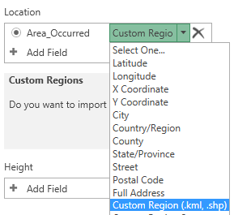

A box will pop up asking whether we want to import custom regions. Press yes.

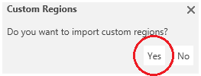

Browse for districts.kml and open it.

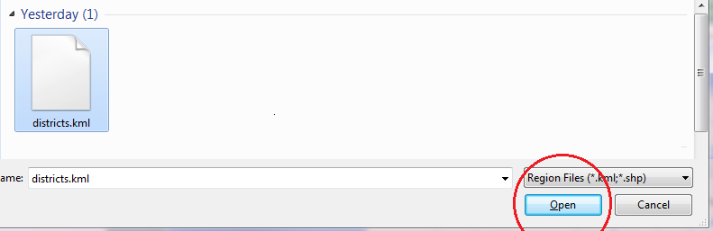

We will want to import the custom region set REPDIST.

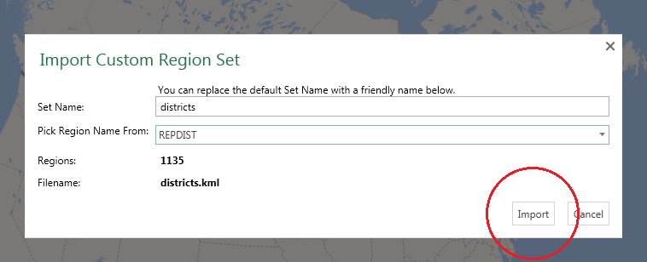

Continue on and fill the the fields for Height, Category, and Time. Set the Height as Incident_Number and set it to (Count - Not Blank), Category has Call_Type_Description, and Time as Dispatch_Date and set it to (Month).

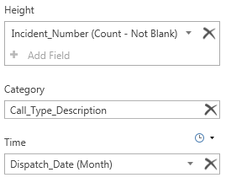

Zoom into the area. We should now be able to play the result and see the count of service calls over the last 9 years.



Remember that we made a query in hive looking for the top 10 types of call descriptions. We will now visualize the results in Excel 3d maps.



Start by hiding Layer 1 and creating a Layer 2.

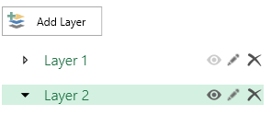

Start by setting the fields Location, Height and Category just like we had in Layer 1. This time we will be adding filters. Excel 3d maps is unable to show the filters we want to use because there are too many. The filter “Count of Call_Type_Description” will need to be used to cut down on filter options. Move slider that appears to a minimum of 405 counts. After lowering the number of filters to choose from we can add another filter for Call_Type_Description and select the top 10 call descriptions.

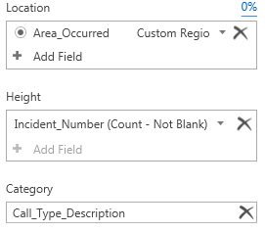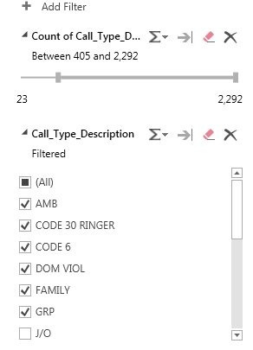

Zoom in to see the results for top 10 call descriptions in the 77th street area from 2010-2018.

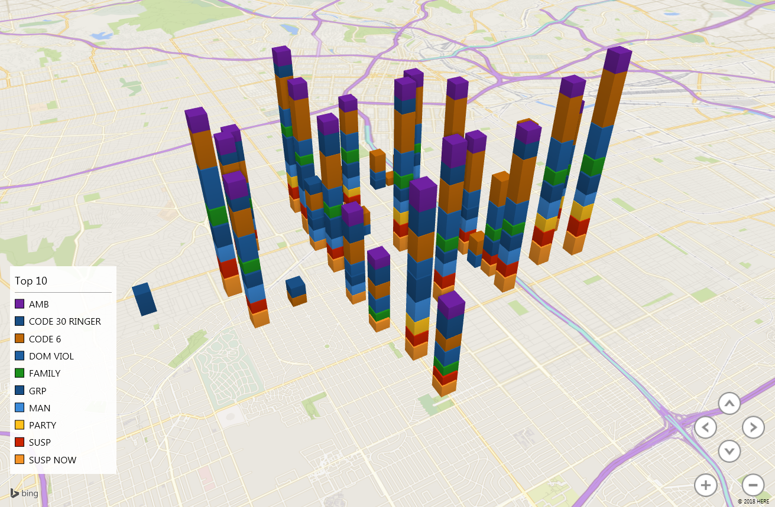

References

* 1. URL of Data Source:

<https://data.lacity.org/api/views/iy4q-t9vr/rows.csv?accessType=DOWNLOAD>

<https://data.lacity.org/api/views/4tmc-7r6g/rows.csv?accessType=DOWNLOAD>

<https://data.lacity.org/api/views/i7pm-cnmm/rows.csv?accessType=DOWNLOAD>

<https://data.lacity.org/api/views/urhh-yf63/rows.csv?accessType=DOWNLOAD>

<https://data.lacity.org/api/views/mgue-vbsx/rows.csv?accessType=DOWNLOAD>

<https://data.lacity.org/api/views/tss8-455b/rows.csv?accessType=DOWNLOAD>

<https://data.lacity.org/api/views/xwgr-xw5q/rows.csv?accessType=DOWNLOAD>

* 1. URL of Github:

<https://github.com/mrandrewlai/Lapd-Crime-Data/blob/master/5200%20Project>